Library Update 2020, August 26, 2020

Aimee Sgourakis, aimees@pitt.edu
My office hours are TUESDAYS 10am - 12pm via Zoom and scheduled by appointment.
For the latest information on library services and COVID-19 protocols, visit: https://www.library.pitt.edu/library-response-resources

Here is an overview of what I can help you with:
- Research needs or questions from students, staff, and faculty
- Library instruction services: virtual visits and/or designing a customized research guide (LibGuide) for your course linkable in Canvas, citation management instruction (Zotero)
- Digital scholarship needs or questions: copyright issues, open access author fee fund, open access publishing, data management, our digital repository, citation metrics, altmetrics, journal metrics
- Collection needs (ordering books, journals, databases) We are prioritizing online access to ebooks and streaming video.
- One-on-one consultation services

Research Support & Consultation
Guide your students directly to me, their subject specialist librarian, for library or research help in your classes. I can assist via consultation (via Zoom or email.)
- If your students do visit the Hillman ground floor service desk in-person, they will not be provided with introductory research guidance. If the student has questions, desk staff will put them in contact with me (or the appropriate library expert or specialist) to schedule a consultation or with the general Ask Us email/chat as appropriate.

Consider a Library Statement for your syllabus or to share only with students:

Hillman Library Services & Resources
You have a personal librarian! Contact Aimee Sgourakis, liaison librarian to the Psychology Program. She is here to answer questions about library services and resources. Please email her at aimees@pitt.edu. Get personalized, in-depth assistance on your research papers and projects by visiting her during Tuesday office hours via Zoom (10am - 12 pm) or scheduling by appointment.

Hillman Library Updates

Hillman Library will re-open on Monday August 24, 2020 with COVID-19 protocols in place
Hillman Hours: 10-8 Monday through Friday, 10-5 Saturday and Sunday. All other library facilities will be open (except for the Music Library)– with some reductions in hours and with occupancy limits in place – starting on August 24th. The full print collection will be available for circulation at that time.
- Faculty can request that items be pulled for them, held for no contact pickup, or shipped to their homes from within the request process in PittCat.
New PittCat / New Website / New Databases A to Z
There is a new discovery layer for our subscription content and library catalog, PittCat. For the best user experience, Sign In in the upper right corner. https://pitt.primo.exlibrisgroup.com/

PittCat Classic has been removed, but you can search just the library catalog for known item searching.
- Use the green magnifying glass and choose Library Catalog from the drop-down.
- You can also use the Advanced Search, and limit to Title and Resource Type, Books.
- Both methods will find our print collections and ebooks.
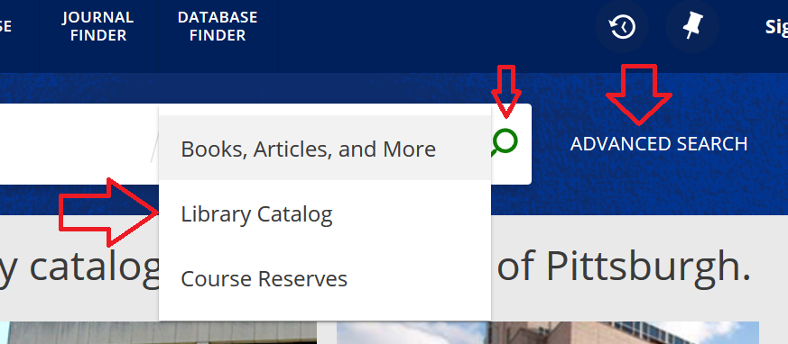

We will be hosting general training sessions for faculty and students to introduce PittCat and its features.
- Workshop: Welcome to the New PittCat Description: All are welcome to join us for an overview of the new PittCat and introduction to search functionality. Workshop presenters will review basic and advanced features of the system, followed by Q&A. The Zoom session will be recorded and shared with attendees. Advanced registration is required through the links below.
- Dates/Times:
  - August 25th 3:00-4:00pm | https://pitt.libcal.com/event/6927547
  - September 1st 3:00-4:00pm | https://pitt.libcal.com/event/6927582
  - September 8th 3:00-4:00pm | https://pitt.libcal.com/event/6927556
  - September 15th 3:00-4:00pm | https://pitt.libcal.com/event/6927583

There is also a new library website and a new way that the A to Z list of database information is displayed. https://pitt.libguides.com/az.php

Required Class Readings/Books/Textbooks: I can check for availability and then purchase ebook user access to titles that you recommend for your classes. We may already have them available!
- Online eReserves: Currently, we are only placing e-reserves requests for your students for classes. Our ground floor service desk handles reserves that will adhere to copyright guidelines. Place a request: https://library.pitt.edu/e-reserves-request
  - Due to copyright, we are not able to scan full book titles for ereserve. We can scan 10% of a book for ereserve.

Stark Media Services (Film & Audio Collection): https://library.pitt.edu/media-services
- Ask Us to Buy Films or Other Media: https://library.pitt.edu/media-purchase-form
  - We have been working with many of you to identify streaming media content for your courses and will continue to do so. We are purchasing from Kanopy.
  - For Oakland fall 2020, access to Stark collections will be possible upon request at the Donald S. Wood Service Desk on the ground floor. Library staff will retrieve the materials requested and bring them to the Service Desk for checkout.
- Place Physical Media on Reserve: https://library.pitt.edu/request-course-reserves
  - For Oakland fall 2020, we will have physical media on reserve at the Donald S. Wood Service Desk on the ground floor of Hillman Library, as the Stark Media Services area will be open by appointment only this Fall and not offer regular open hours. Any students who need to access these materials will need to approach the Service Desk to borrow the materials. There will be two viewing stations available in Hillman Library.
- Here is the recommendation from the Teaching Center on presenting a DVD during class.
  - https://canvas.pitt.edu/courses/22884/pages/presenting-a-dvd-to-students
- All of this information is gathered on this LibGuide that I will be updating, along with links to databases for streaming: https://pitt.libguides.com/multimedia/video
Reserve Equipment: https://pitt.libguides.com/equipment
Reserve Equipment is available only to those students enrolled in courses with special borrowing privileges. To borrow Course Reserve Equipment, students must be enrolled in one of the approved classes that have submitted a roster to Hillman Library and who are permitted to borrow equipment.

Hillman Equipment Collection: https://pitt.libguides.com/equipment/hillmanequipmentcollection
All students, faculty, and staff with a current University of Pittsburgh ID card are eligible to borrow equipment from the Hillman Equipment Collection during our hours of operation.

NEW! The Text & conText Lab: https://library.pitt.edu/text-context-lab
A Center for Creativity/University Library System partnership on the Third Floor of Hillman Library, provides an active environment for the creation, manipulation, and/or disassembly of text. Text & conText is open to all Pitt students, faculty, and staff. Both individual and group work can be accommodated; this is a space for experiential activity rather than study!

One-Button Studio: https://www.library.pitt.edu/one-button (two-person capacity limit)
There is a one-button, reservable studio on the ground floor of Hillman for anyone to record videos.

Whisper Room Sound Isolated Recording Booth: https://www.library.pitt.edu/whisper-room
(one-person capacity limit) A sound-isolated booth that is ideal for making audio recordings for both podcast and video projects.

Hillman Film Screening & Group Study Room: http://pitt.libcal.com
Room 237 is available as a self-service screening/group study area through Reserve a Group Study Space on the ULS website. The room can be reserved for 3 consecutive hours. (four-person capacity limit)

Hillman Library Renovation: http://www.library.pitt.edu/hillmanreinvention
The 3rd floor renovation is finished, and the floor will be open. The first and second floor construction will start late next spring, possibly March 2021.

Fall Workshops via Zoom: https://pitt.libcal.com/calendar/today/
- Introduction to ArcGIS Online & ArcGIS StoryMaps: Tuesday, September 8
- Using the Faculty Information System (Elements) to manage information about your publications: Thursday, September 10
- White Privilege in Information: Monday, September 21
- And many more through the term!

Archives & Special Collections: Our Archives & Special Collections unit is here to work with you to bring primary materials into your classroom and is available for in-person visits (capacity limit 12) and Zoom visits. Contact Jeanann Haas jeanann@pitt.edu.

Archival Scholars Research Awards in the Spring: Consider mentoring an undergraduate student in archival research through OUR. $1000 stipend for the student. These will be virtual experiences using ULS Digital Collections. Contact Jeanann Haas jeanann@pitt.edu.

Digital Scholarship Services: https://library.pitt.edu/digital-scholarship-commons
- DSS offers support for Research Data Management, Data Acquisition and Analysis , Mapping and Geographic Information Systems , Digital Curation and Stewardship, Metadata, Vocabularies, and Linked Data, Multimedia and Web-based Scholarship through consultations and open office hours via Zoom.
- 3D scanning is now available as a drop off service! At this point the service will be limited to faculty and internal ULS use, to scan 3D physical materials that are necessary for online instruction and remote/distance education. We are also available to provide synchronous and asynchronous classroom instruction and/or consultations about the use of 3D and other digitization techniques.

Consider a Library Statement for your syllabus or to share only with students:

Hillman Library Services & Resources
You have a personal librarian! Contact Aimee Sgourakis, liaison librarian to the Psychology Program. She is here to answer questions about library services and resources. Please email her at aimees@pitt.edu. Get personalized, in-depth assistance on your research papers and projects by visiting her during Tuesday office hours via Zoom (10am - 12 pm) or scheduling by appointment.

